EDA: Housing Dominican Republic

# Introduction

For this analysis, we will examine the effect that area (measured in squared meters) has on the value of apartment, for residential use, in Santo Domingo, Domincan Republic. Prices and apartment’s characteristics are collect via web scraping. Specifically, data were retrieved on 22nd of march, 2022, from supercasas.com, a beacon on the online dominican real estate market.

# Loading libraries and data

rm(list = ls())  
  
options(scipen = 999)  
  
library(robustbase)  
library(tidyverse)  
library(caret)  
  
set.seed(1234)

Data on every listing available on several dates at supercasas.com were retrieved. Here, we load and filter said data so we only have information on apartments for residential use on the date of interest. Then, we split the dataset into training (70%) and testing (30%).

path <- "../1_data/0_raw/housing price/"  
housing_files <- list.files(path)  
housing <- read_csv(paste0(path, housing_files))

## Warning in gzfile(file, mode): cannot open compressed file 'C:/Users/Augus/  
## AppData/Local/Temp/Rtmpwvjzst\file5a7c12142fc4', probable reason 'No such file  
## or directory'

## Rows: 24575 Columns: 25  
## ── Column specification ────────────────────────────────────────────────────────  
## Delimiter: ","  
## chr (8): id, currency, seller, neighborhood, city, province, status, usage  
## dbl (7): parking, bathrooms, bedrooms, price, area, story, price.usd  
## lgl (9): planta, lift, pool, pozo, terraza, lobby, balcon, jacuzzi, gimnasio  
## date (1): date  
##   
## ℹ Use `spec()` to retrieve the full column specification for this data.  
## ℹ Specify the column types or set `show_col_types = FALSE` to quiet this message.

housing <- housing %>%  
 filter(date == "2022-03-22",  
 usage == "Residencial",  
 province %in% c("Santo Domingo", "Santo Domingo Centro (D.N.)")) %>%  
 rename(location = neighborhood) %>%  
 select(-c(date, usage, city, province))  
  
inTrain <- createDataPartition(housing$price.usd, p = 0.7, list = FALSE)  
  
training <- housing[inTrain, ]  
testing <- housing[-inTrain, ]

# Data cleaning

First, let’s see what’s on the dataset:

glimpse(training)

## Rows: 4,154  
## Columns: 21  
## $ id <chr> "/apartamentos-venta-piantini/1265273/", "/apartamentos-vent…  
## $ parking <dbl> 3, 2, 2, 3, NA, 3, 2, 2, 2, 1, 3, 1, 3, 3, 3, 1, 2, 1, 2, 2,…  
## $ bathrooms <dbl> 3.0, 2.5, 2.5, 3.5, 3.5, 3.5, 3.5, 3.5, 2.5, 2.0, 3.0, 1.5, …  
## $ bedrooms <dbl> 2, 2, 2, 3, 3, 3, 3, 3, 2, 1, 2, 1, 3, 3, 3, 1, 1, 1, 2, 3, …  
## $ currency <chr> "US$", "US$", "US$", "US$", "US$", "US$", "US$", "US$", "US$…  
## $ price <dbl> 258000, 220000, 296250, 408825, 390000, 370000, 275000, 3000…  
## $ seller <chr> "BAEZ MUESES INMOBILIARIA", "Premium Real Estate", "Algonovo…  
## $ location <chr> "Piantini", "Piantini", "Piantini", "Piantini", "Piantini", …  
## $ status <chr> "Segundo Uso", "Segundo Uso", "En Construcción", "En Constru…  
## $ area <dbl> 180, 100, 153, 185, NA, 217, NA, NA, 142, NA, 225, 70, 175, …  
## $ story <dbl> 2, 2, 4, 3, NA, NA, NA, NA, NA, NA, NA, NA, 3, 13, NA, NA, N…  
## $ planta <lgl> TRUE, FALSE, TRUE, TRUE, FALSE, FALSE, TRUE, TRUE, TRUE, TRU…  
## $ lift <lgl> TRUE, TRUE, TRUE, TRUE, FALSE, TRUE, TRUE, TRUE, TRUE, TRUE,…  
## $ pool <lgl> TRUE, TRUE, TRUE, TRUE, TRUE, FALSE, FALSE, FALSE, FALSE, FA…  
## $ pozo <lgl> TRUE, FALSE, TRUE, TRUE, FALSE, FALSE, FALSE, FALSE, FALSE, …  
## $ terraza <lgl> TRUE, TRUE, TRUE, TRUE, FALSE, TRUE, FALSE, FALSE, FALSE, TR…  
## $ lobby <lgl> TRUE, TRUE, TRUE, TRUE, TRUE, TRUE, FALSE, FALSE, FALSE, FAL…  
## $ balcon <lgl> TRUE, TRUE, TRUE, TRUE, FALSE, FALSE, FALSE, FALSE, FALSE, F…  
## $ jacuzzi <lgl> FALSE, FALSE, FALSE, FALSE, FALSE, FALSE, FALSE, FALSE, FALS…  
## $ gimnasio <lgl> TRUE, TRUE, TRUE, TRUE, TRUE, TRUE, FALSE, FALSE, FALSE, FAL…  
## $ price.usd <dbl> 258000, 220000, 296250, 408825, 390000, 370000, 275000, 3000…

Our training dataset contains 4,154 observations and 21 variables. Of them, we can highlight price, currency and price.usd. price and currency is the actual price shown in the listing’s site. They can be in local currency or US dollars, depending on the seller’s preference. price.usd is a user-made feature of prices in US dollars. Hence, if prices were stated in local currency, they were converted into US dollars. Otherwise, they stay the same. We’ll drop currency and price and keep price.usd. Then, and for simplicity’s sake, we’ll rename price.usd as price.

training <- training %>%  
 select(-c(currency, price)) %>%  
 rename(price = price.usd)

When looking at the proportion of NAs are present per variable, over 50% of listings did not provide information regarding the floor the apartment is located at. The proportion of missing values for all other variables is acceptable. And so, we removed that variable.

apply(training, 2,   
 \(x) {  
 n <- length(x)  
 na <- x %>%  
 is.na() %>%  
 sum()  
 prop.na <- na / n * 100  
 })

## id parking bathrooms bedrooms seller location status   
## 0.0000000 6.7645643 5.0072220 2.4795378 0.0000000 0.4573905 6.6441984   
## area story planta lift pool pozo terraza   
## 10.7125662 51.4443909 0.0000000 0.0000000 0.0000000 0.0000000 0.0000000   
## lobby balcon jacuzzi gimnasio price   
## 0.0000000 0.0000000 0.0000000 0.0000000 0.0000000

training <- training %>%  
 select(-c(story))

Before implementing some formal procedure for outlier removal, let’s analyse the data at hand. First, we can see that area has some outstanding observations: a minimum value of 30 and a maximum of 650,000.

summary(training)

## id parking bathrooms bedrooms   
## Length:4154 Min. : 1.000 Min. :1.000 Min. :1.000   
## Class :character 1st Qu.: 2.000 1st Qu.:2.000 1st Qu.:2.000   
## Mode :character Median : 2.000 Median :2.500 Median :3.000   
## Mean : 2.012 Mean :2.719 Mean :2.554   
## 3rd Qu.: 2.000 3rd Qu.:3.500 3rd Qu.:3.000   
## Max. :25.000 Max. :6.500 Max. :6.000   
## NA's :281 NA's :208 NA's :103   
## seller location status area   
## Length:4154 Length:4154 Length:4154 Min. : 30.0   
## Class :character Class :character Class :character 1st Qu.: 100.0   
## Mode :character Mode :character Mode :character Median : 151.0   
## Mean : 582.8   
## 3rd Qu.: 220.0   
## Max. :650000.0   
## NA's :445   
## planta lift pool pozo   
## Mode :logical Mode :logical Mode :logical Mode :logical   
## FALSE:1516 FALSE:1283 FALSE:2732 FALSE:2962   
## TRUE :2638 TRUE :2871 TRUE :1422 TRUE :1192   
##   
##   
##   
##   
## terraza lobby balcon jacuzzi   
## Mode :logical Mode :logical Mode :logical Mode :logical   
## FALSE:2424 FALSE:1665 FALSE:1307 FALSE:3372   
## TRUE :1730 TRUE :2489 TRUE :2847 TRUE :782   
##   
##   
##   
##   
## gimnasio price   
## Mode :logical Min. : 1   
## FALSE:1991 1st Qu.: 138000   
## TRUE :2163 Median : 210000   
## Mean : 496043   
## 3rd Qu.: 300000   
## Max. :257500000   
##

By viewing the “largest apartments”, some things become apparent. First, the are repeated observations on this small sample: see the third and fourth rows, for instance. Second, the first four rows are obviously typos: the seller typed 650,000 instead of 650 squared meters, to cited the first case. Third, the apartment listed on the fifth row is no longer available rising some doubts on its veracity. Last, the sixth “apartment” is actually a house. When analysing the “smallest apartments”, everything seems in order.

training %>%  
 arrange(desc(area)) %>%  
 head(10)

## # A tibble: 10 × 18  
## id parking bathrooms bedrooms seller location status area planta lift   
## <chr> <dbl> <dbl> <dbl> <chr> <chr> <chr> <dbl> <lgl> <lgl>  
## 1 /apart… 5 3.5 3 Flavi… Piantini Segun… 650000 TRUE TRUE   
## 2 /apart… 3 3.5 3 Flavi… Piantini Segun… 400000 TRUE TRUE   
## 3 /apart… 2 3.5 3 Premi… Alma Ro… En Co… 220000 TRUE TRUE   
## 4 /apart… 2 3.5 3 Premi… Alma Ro… En Co… 220000 TRUE TRUE   
## 5 /apart… 3 3.5 3 Gineb… Los Cac… Segun… 2016 FALSE FALSE  
## 6 /apart… NA 5.5 5 Vícto… Cuesta … Segun… 1431 TRUE FALSE  
## 7 /apart… NA 5 4 Patri… Paraiso Segun… 952 TRUE TRUE   
## 8 /apart… 4 6 4 Paez … La Espe… Segun… 890 FALSE FALSE  
## 9 /apart… NA NA 4 Paez … Anacaona <NA> 890 FALSE FALSE  
## 10 /apart… 5 4.5 4 Flavi… Anacaona Segun… 854 FALSE TRUE   
## # … with 8 more variables: pool <lgl>, pozo <lgl>, terraza <lgl>, lobby <lgl>,  
## # balcon <lgl>, jacuzzi <lgl>, gimnasio <lgl>, price <dbl>

So, to fix these (1) we eliminate duplicates, (2) we divide by 1,000 the area of those apartments with over 10,000 squared meters of area, (3) remove those apartments that are obviously not of interest.

training <- training %>%  
 filter(id != "/apartamentos-venta-cuesta-hermosa-ii/1236477/",  
 id != "/apartamentos-venta-los-cacicazgos/1272251/") %>%  
 mutate(area = ifelse(area > 10000, area / 1000, area)) %>%  
 unique()

Let’s do the same with price. Viewing price alone might be misleading as a apartment with 30 squared meters could be worth 20,000 dollars, but one with 280 squared meters could hardly be worth $10,256. Price per squared meter could tell us more about how extreme of a value it is.

summary(training$price)

## Min. 1st Qu. Median Mean 3rd Qu. Max.   
## 1 142000 215000 528651 315000 257500000

training <- training %>%  
 mutate(price_per_m2 = price / area,  
 area_per_br = area / bedrooms)

Anything below $200 seems rather dubious, right? Let’s filter them out.But let’s use something less subjective.

(cutoff <- adjboxStats(training$price_per_m2)$fence)

## The default of 'doScale' is FALSE now for stability;  
## set options(mc_doScale_quiet=TRUE) to suppress this (once per session) message

## [1] 226.7685 3270.8771

training <- training %>%  
 filter(between(price_per_m2, cutoff[1], cutoff[2]))  
  
summary(training$price_per_m2)

## Min. 1st Qu. Median Mean 3rd Qu. Max.   
## 268.9 1100.0 1456.3 1505.9 1847.7 3219.2

Anything below $200 seems rather dubious, right? Let’s filter them out.But let’s use something less subjective.

(cutoff <- adjboxStats(training$area_per_br)$fence)

## [1] 27.28568 153.12550

training <- training %>%  
 filter(between(area_per_br, cutoff[1], cutoff[2]))  
  
summary(training$area_per_br)

## Min. 1st Qu. Median Mean 3rd Qu. Max.   
## 27.33 51.67 64.00 68.33 80.00 150.00

glimpse(training)

## Rows: 2,851  
## Columns: 20  
## $ id <chr> "/apartamentos-venta-piantini/1265273/", "/apartamentos-v…  
## $ parking <dbl> 3, 2, 2, 3, 3, 2, 3, 3, 3, 3, 1, 2, 1, 2, 2, 3, 2, 3, 3, …  
## $ bathrooms <dbl> 3.0, 2.5, 2.5, 3.5, 3.5, 2.5, 3.0, 3.5, 3.5, 3.5, 1.5, 1.…  
## $ bedrooms <dbl> 2, 2, 2, 3, 3, 2, 2, 3, 3, 3, 1, 1, 1, 3, 3, 3, 2, 3, 3, …  
## $ seller <chr> "BAEZ MUESES INMOBILIARIA", "Premium Real Estate", "Algon…  
## $ location <chr> "Piantini", "Piantini", "Piantini", "Piantini", "Piantini…  
## $ status <chr> "Segundo Uso", "Segundo Uso", "En Construcción", "En Cons…  
## $ area <dbl> 180, 100, 153, 185, 217, 142, 225, 175, 200, 340, 67, 103…  
## $ planta <lgl> TRUE, FALSE, TRUE, TRUE, FALSE, TRUE, FALSE, TRUE, TRUE, …  
## $ lift <lgl> TRUE, TRUE, TRUE, TRUE, TRUE, TRUE, TRUE, TRUE, FALSE, TR…  
## $ pool <lgl> TRUE, TRUE, TRUE, TRUE, FALSE, FALSE, FALSE, FALSE, TRUE,…  
## $ pozo <lgl> TRUE, FALSE, TRUE, TRUE, FALSE, FALSE, FALSE, FALSE, FALS…  
## $ terraza <lgl> TRUE, TRUE, TRUE, TRUE, TRUE, FALSE, FALSE, FALSE, FALSE,…  
## $ lobby <lgl> TRUE, TRUE, TRUE, TRUE, TRUE, FALSE, FALSE, TRUE, TRUE, T…  
## $ balcon <lgl> TRUE, TRUE, TRUE, TRUE, FALSE, FALSE, FALSE, FALSE, TRUE,…  
## $ jacuzzi <lgl> FALSE, FALSE, FALSE, FALSE, FALSE, FALSE, FALSE, TRUE, FA…  
## $ gimnasio <lgl> TRUE, TRUE, TRUE, TRUE, TRUE, FALSE, FALSE, TRUE, TRUE, T…  
## $ price <dbl> 258000, 220000, 296250, 408825, 370000, 155000, 280000, 3…  
## $ price_per_m2 <dbl> 1433.333, 2200.000, 1936.275, 2209.865, 1705.069, 1091.54…  
## $ area_per_br <dbl> 90.00000, 50.00000, 76.50000, 61.66667, 72.33333, 71.0000…

Our data frame is now 20 columns wide and 2,851 rows long.

Many times, the same apartment is listed by different sellers. So, eliminating duplicates is not enough to remove confliting. Some seller are not as rigourous as to list all the amaneties, so we are going to keep the most complete listing:

# Some feature engineering

Now, let’s do some feature engineering to help the analysis:

glimpse(training)

## Rows: 2,851  
## Columns: 20  
## $ id <chr> "/apartamentos-venta-piantini/1265273/", "/apartamentos-v…  
## $ parking <dbl> 3, 2, 2, 3, 3, 2, 3, 3, 3, 3, 1, 2, 1, 2, 2, 3, 2, 3, 3, …  
## $ bathrooms <dbl> 3.0, 2.5, 2.5, 3.5, 3.5, 2.5, 3.0, 3.5, 3.5, 3.5, 1.5, 1.…  
## $ bedrooms <dbl> 2, 2, 2, 3, 3, 2, 2, 3, 3, 3, 1, 1, 1, 3, 3, 3, 2, 3, 3, …  
## $ seller <chr> "BAEZ MUESES INMOBILIARIA", "Premium Real Estate", "Algon…  
## $ location <chr> "Piantini", "Piantini", "Piantini", "Piantini", "Piantini…  
## $ status <chr> "Segundo Uso", "Segundo Uso", "En Construcción", "En Cons…  
## $ area <dbl> 180, 100, 153, 185, 217, 142, 225, 175, 200, 340, 67, 103…  
## $ planta <lgl> TRUE, FALSE, TRUE, TRUE, FALSE, TRUE, FALSE, TRUE, TRUE, …  
## $ lift <lgl> TRUE, TRUE, TRUE, TRUE, TRUE, TRUE, TRUE, TRUE, FALSE, TR…  
## $ pool <lgl> TRUE, TRUE, TRUE, TRUE, FALSE, FALSE, FALSE, FALSE, TRUE,…  
## $ pozo <lgl> TRUE, FALSE, TRUE, TRUE, FALSE, FALSE, FALSE, FALSE, FALS…  
## $ terraza <lgl> TRUE, TRUE, TRUE, TRUE, TRUE, FALSE, FALSE, FALSE, FALSE,…  
## $ lobby <lgl> TRUE, TRUE, TRUE, TRUE, TRUE, FALSE, FALSE, TRUE, TRUE, T…  
## $ balcon <lgl> TRUE, TRUE, TRUE, TRUE, FALSE, FALSE, FALSE, FALSE, TRUE,…  
## $ jacuzzi <lgl> FALSE, FALSE, FALSE, FALSE, FALSE, FALSE, FALSE, TRUE, FA…  
## $ gimnasio <lgl> TRUE, TRUE, TRUE, TRUE, TRUE, FALSE, FALSE, TRUE, TRUE, T…  
## $ price <dbl> 258000, 220000, 296250, 408825, 370000, 155000, 280000, 3…  
## $ price_per_m2 <dbl> 1433.333, 2200.000, 1936.275, 2209.865, 1705.069, 1091.54…  
## $ area_per_br <dbl> 90.00000, 50.00000, 76.50000, 61.66667, 72.33333, 71.0000…

summary(training)

## id parking bathrooms bedrooms   
## Length:2851 Min. :1.000 Min. :1.000 Min. :1.000   
## Class :character 1st Qu.:2.000 1st Qu.:2.000 1st Qu.:2.000   
## Mode :character Median :2.000 Median :2.500 Median :3.000   
## Mean :2.013 Mean :2.751 Mean :2.552   
## 3rd Qu.:2.000 3rd Qu.:3.500 3rd Qu.:3.000   
## Max. :6.000 Max. :6.500 Max. :6.000   
## NA's :101 NA's :61   
## seller location status area   
## Length:2851 Length:2851 Length:2851 Min. : 30.0   
## Class :character Class :character Class :character 1st Qu.:104.0   
## Mode :character Mode :character Mode :character Median :155.0   
## Mean :177.3   
## 3rd Qu.:222.0   
## Max. :720.0   
##   
## planta lift pool pozo   
## Mode :logical Mode :logical Mode :logical Mode :logical   
## FALSE:933 FALSE:787 FALSE:1881 FALSE:1980   
## TRUE :1918 TRUE :2064 TRUE :970 TRUE :871   
##   
##   
##   
##   
## terraza lobby balcon jacuzzi   
## Mode :logical Mode :logical Mode :logical Mode :logical   
## FALSE:1661 FALSE:1077 FALSE:828 FALSE:2312   
## TRUE :1190 TRUE :1774 TRUE :2023 TRUE :539   
##   
##   
##   
##   
## gimnasio price price_per_m2 area_per_br   
## Mode :logical Min. : 20000 Min. : 425.3 Min. : 27.33   
## FALSE:1317 1st Qu.: 145250 1st Qu.:1107.6 1st Qu.: 51.67   
## TRUE :1534 Median : 217650 Median :1459.5 Median : 64.00   
## Mean : 262042 Mean :1502.3 Mean : 68.33   
## 3rd Qu.: 315000 3rd Qu.:1843.8 3rd Qu.: 80.00   
## Max. :1800000 Max. :3219.2 Max. :150.00   
##

training <- training %>%  
 na.omit()  
  
nonOutlier <- adjOutlyingness(training)  
nonOutlier <- nonOutlier$nonOut  
  
training <- training[nonOutlier, ]  
  
glimpse(training)

## Rows: 2,467  
## Columns: 20  
## $ id <chr> "/apartamentos-venta-piantini/1265273/", "/apartamentos-v…  
## $ parking <dbl> 3, 2, 2, 3, 3, 3, 3, 1, 1, 2, 2, 3, 2, 3, 3, 2, 1, 3, 5, …  
## $ bathrooms <dbl> 3.0, 2.5, 2.5, 3.5, 3.5, 3.5, 3.5, 1.5, 1.5, 3.5, 2.5, 3.…  
## $ bedrooms <dbl> 2, 2, 2, 3, 3, 3, 3, 1, 1, 3, 3, 3, 2, 3, 3, 3, 1, 3, 3, …  
## $ seller <chr> "BAEZ MUESES INMOBILIARIA", "Premium Real Estate", "Algon…  
## $ location <chr> "Piantini", "Piantini", "Piantini", "Piantini", "Piantini…  
## $ status <chr> "Segundo Uso", "Segundo Uso", "En Construcción", "En Cons…  
## $ area <dbl> 180, 100, 153, 185, 175, 200, 340, 67, 65, 170, 192, 221,…  
## $ planta <lgl> TRUE, FALSE, TRUE, TRUE, TRUE, TRUE, TRUE, TRUE, TRUE, TR…  
## $ lift <lgl> TRUE, TRUE, TRUE, TRUE, TRUE, FALSE, TRUE, TRUE, TRUE, TR…  
## $ pool <lgl> TRUE, TRUE, TRUE, TRUE, FALSE, TRUE, TRUE, TRUE, TRUE, FA…  
## $ pozo <lgl> TRUE, FALSE, TRUE, TRUE, FALSE, FALSE, FALSE, TRUE, TRUE,…  
## $ terraza <lgl> TRUE, TRUE, TRUE, TRUE, FALSE, FALSE, TRUE, TRUE, TRUE, T…  
## $ lobby <lgl> TRUE, TRUE, TRUE, TRUE, TRUE, TRUE, TRUE, TRUE, TRUE, TRU…  
## $ balcon <lgl> TRUE, TRUE, TRUE, TRUE, FALSE, TRUE, TRUE, TRUE, TRUE, TR…  
## $ jacuzzi <lgl> FALSE, FALSE, FALSE, FALSE, TRUE, FALSE, TRUE, TRUE, FALS…  
## $ gimnasio <lgl> TRUE, TRUE, TRUE, TRUE, TRUE, TRUE, TRUE, TRUE, TRUE, TRU…  
## $ price <dbl> 258000, 220000, 296250, 408825, 358750, 370000, 695000, 1…  
## $ price_per_m2 <dbl> 1433.333, 2200.000, 1936.275, 2209.865, 2050.000, 1850.00…  
## $ area_per_br <dbl> 90.00000, 50.00000, 76.50000, 61.66667, 58.33333, 66.6666…

summary(training)

## id parking bathrooms bedrooms   
## Length:2467 Min. :1.000 Min. :1.000 Min. :1.000   
## Class :character 1st Qu.:2.000 1st Qu.:2.000 1st Qu.:2.000   
## Mode :character Median :2.000 Median :2.500 Median :3.000   
## Mean :1.988 Mean :2.731 Mean :2.533   
## 3rd Qu.:2.000 3rd Qu.:3.500 3rd Qu.:3.000   
## Max. :6.000 Max. :6.000 Max. :5.000   
## seller location status area   
## Length:2467 Length:2467 Length:2467 Min. : 36.0   
## Class :character Class :character Class :character 1st Qu.:105.0   
## Mode :character Mode :character Mode :character Median :154.0   
## Mean :171.6   
## 3rd Qu.:220.0   
## Max. :554.0   
## planta lift pool pozo   
## Mode :logical Mode :logical Mode :logical Mode :logical   
## FALSE:741 FALSE:636 FALSE:1621 FALSE:1665   
## TRUE :1726 TRUE :1831 TRUE :846 TRUE :802   
##   
##   
##   
## terraza lobby balcon jacuzzi   
## Mode :logical Mode :logical Mode :logical Mode :logical   
## FALSE:1411 FALSE:880 FALSE:650 FALSE:1997   
## TRUE :1056 TRUE :1587 TRUE :1817 TRUE :470   
##   
##   
##   
## gimnasio price price_per_m2 area_per_br   
## Mode :logical Min. : 30462 Min. : 425.3 Min. : 27.33   
## FALSE:1107 1st Qu.: 146726 1st Qu.:1117.7 1st Qu.: 51.67   
## TRUE :1360 Median : 217000 Median :1475.4 Median : 63.33   
## Mean : 253166 Mean :1506.6 Mean : 67.06   
## 3rd Qu.: 301000 3rd Qu.:1847.4 3rd Qu.: 78.67   
## Max. :1100000 Max. :3219.2 Max. :150.00

#training <- training[complete.cases(training), ]  
#dim(training)

Now, our data.frame has 2,467 observations and 20 variables.

# Final removal of outliers

trn <- training %>%  
 mutate(no_amenities = rowSums(across(planta:gimnasio))) %>%  
 arrange(desc(no_amenities)) %>%  
 distinct(bathrooms, bedrooms, area, price,  
 .keep_all = TRUE)  
  
# Box-Cox tranform  
bc <- with(training,  
 MASS::boxcox(price ~ area * location))

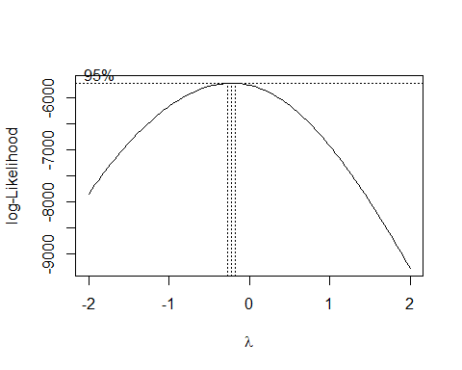

(lambda <- bc$x[which.max(bc$y)])

## [1] -0.2222222

new_model <- lm((price ^ lambda - 1)/lambda ~ area, data = training)  
  
ggplot(training, aes(x = (price ^ lambda-1)/lambda)) +  
geom_histogram(aes(y = ..density..),  
 colour = 1, fill = "white") +  
 geom_density() +  
 stat_function(fun = dnorm,  
 args = list(mean = mean((training$price ^ lambda-1)/lambda),  
 sd = sd((training$price ^ lambda-1)/lambda)),  
 col = "#1b98e0")

## `stat_bin()` using `bins = 30`. Pick better value with `binwidth`.

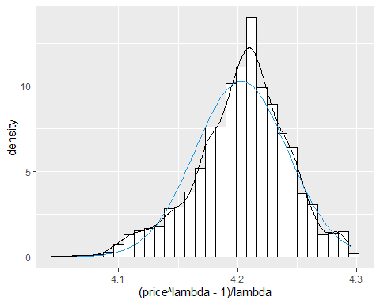

ggplot(training, aes(x = log(price))) +  
 geom_histogram(aes(y = ..density..),  
 colour = 1, fill = "white") +  
 geom_density() +  
 stat_function(fun = dnorm,  
 args = list(mean = mean(log(training$price)),  
 sd = sd(log(training$price))),  
 col = "#1b98e0")

## `stat_bin()` using `bins = 30`. Pick better value with `binwidth`.

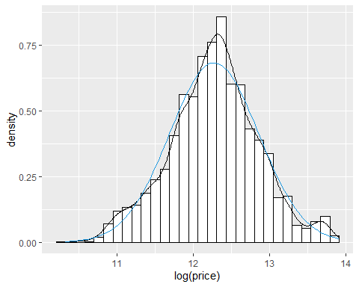

ggplot(trn, aes(x = log(price))) +  
 geom_histogram(aes(y = ..density..),  
 colour = 1, fill = "white") +  
 geom_density() +  
 stat_function(fun = dnorm,  
 args = list(mean = mean(log(trn$price)),  
 sd = sd(log(trn$price))),  
 col = "#1b98e0")

## `stat_bin()` using `bins = 30`. Pick better value with `binwidth`.

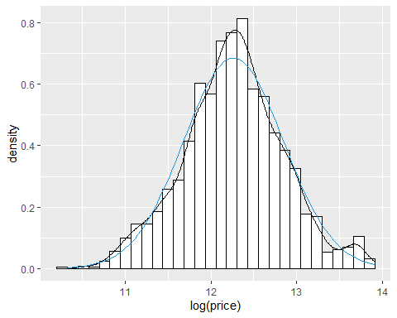

ggplot(training, aes(x = log(area))) +  
 geom_histogram(aes(y = ..density..),  
 colour = 1, fill = "white") +  
 geom_density() +  
 stat_function(fun = dnorm,  
 args = list(mean = mean(log(training$area)),  
 sd = sd(log(training$area))),  
 col = "#1b98e0")

## `stat_bin()` using `bins = 30`. Pick better value with `binwidth`.

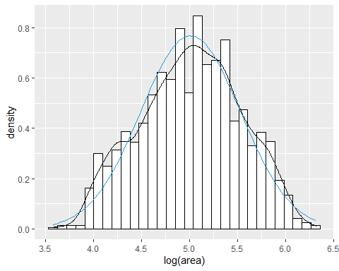

ggplot(trn, aes(x = log(area))) +  
 geom_histogram(aes(y = ..density..),  
 colour = 1, fill = "white") +  
 geom_density() +  
 stat_function(fun = dnorm,  
 args = list(mean = mean(log(trn$area)),  
 sd = sd(log(trn$area))),  
 col = "#1b98e0")

## `stat_bin()` using `bins = 30`. Pick better value with `binwidth`.

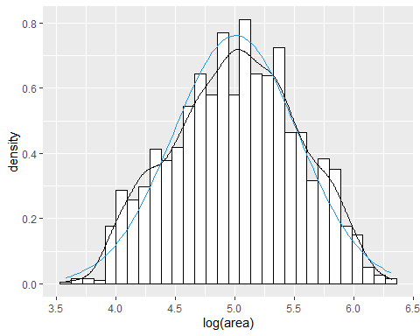

dec_training <- training %>%  
 mutate(decile = cut(log(price), breaks = seq(10, 20, length = 30))) %>%  
 group_by(decile) %>%  
 summarise(n = n())  
  
dec_trn <- trn %>%  
 mutate(decile = cut(log(price), breaks = seq(10, 20, length = 30))) %>%  
 group_by(decile) %>%  
 summarise(n = n())  
  
dec_training %>%  
 left_join(dec_trn, by = "decile") %>%  
 mutate(d = n.x - n.y,  
 d_per = (n.y / n.x - 1) * 100)

## # A tibble: 12 × 5  
## decile n.x n.y d d_per  
## <fct> <int> <int> <int> <dbl>  
## 1 (10,10.3] 1 1 0 0   
## 2 (10.3,10.7] 3 3 0 0   
## 3 (10.7,11] 52 37 15 -28.8   
## 4 (11,11.4] 123 108 15 -12.2   
## 5 (11.4,11.7] 212 191 21 -9.91  
## 6 (11.7,12.1] 448 396 52 -11.6   
## 7 (12.1,12.4] 667 571 96 -14.4   
## 8 (12.4,12.8] 481 397 84 -17.5   
## 9 (12.8,13.1] 309 258 51 -16.5   
## 10 (13.1,13.4] 100 82 18 -18   
## 11 (13.4,13.8] 63 54 9 -14.3   
## 12 (13.8,14.1] 8 8 0 0

shapiro.test(log(training$area))

##   
## Shapiro-Wilk normality test  
##   
## data: log(training$area)  
## W = 0.99049, p-value = 0.00000000001059

# Some more feature engineering

Working on location:

#other_loc <- training %>%  
# group_by(location) %>%  
# summarise(n = n()) %>%  
# filter(n < 10) %>%  
# .$location  
  
#training <- training %>%  
# mutate(location = ifelse(location %in% other_loc, "Other", location),  
# location = factor(location))

status is an ordered categorical variable:

#training <- training %>%  
# mutate(status = factor(status, levels = c("En Planos", "En Construcción",  
# "Nueva", "Remodelada", "A Remodelar",  
# "Segundo Uso", "Fideicomiso")))

Transforming other character variables into factor variables: